**US Stocks Analysis Report**

**Prepared by : Prafull Gosavi**

**Date : 04-05-2024**

**Executive Summary**

This report presents a comprehensive analysis of United State Stocks data over the period of 2020 to 2024. Key performance indicators, Maximum stocks prices over years months, also a minimum stocks prices over years, and average stocks prices over years, compare the google and stock prices over years ect. This report leverages visualizations created in Power BI and also in the Excel and also perform EDA using Python. to facilitate the understanding of complex data patterns.

**Table of Contents**

1. Introduction
2. Methodology
3. Market Overview
4. Analysis and Findings
   1. Data Overview
   2. Min & Max Apple stocks price over years
   3. Average gold stock price over years
   4. Average silver stock price over years.
   5. Average amazon and Netflix prices by years.
   6. Average Netflix and avg amazon price by years.
   7. Minimum meta and Microsoft stock price by years.
   8. Average apple stock price over years.
   9. Minimum and Maximum Bitcoin price by years.
   10. Average Apple and Tesla stock price by years.
   11. Excel Dashboard of US stock data.

**1.Introduction:**

Briefly introduce the purpose and scope of the report.

Explain the significance of analyzing stock market data for the specified timeframe.

**2.Methodology:**

Describe the data sources, tools, and techniques used for the analysis.

Explain any specific methodologies or models employed for data interpretation.

**3.Market Overview:**

Present an overview of the US stock market, including major indices (e.g., Google, Gold, Silver, Microsoft, S&P 500,).

Highlight the overall performance trends observed during the period under review.

**Key Findings:**

Summarize the main findings derived from the analysis of the stock market data.

Include insights on market trends in trading volume, etc.

**4. Analysis and Findings**

***4.1 Data Overview***

The dataset contains US Stock market dataset of year 2020 to 2024.

***4.2 Min & Max Apple stocks price over years***

**Visualization 1**: bar chart showcase the max and min apple stock price over years.

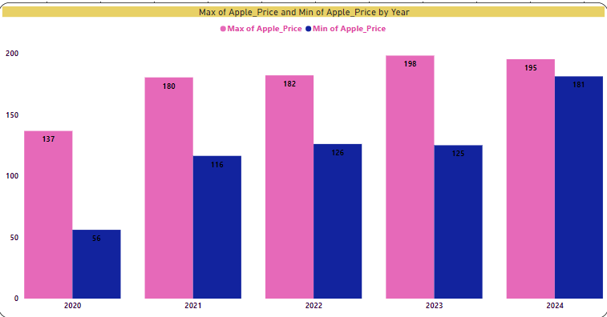

***Description:*** The highest apple stock price over the four year is 198$ in 2023 and the lowest apple stock price over the four year is 56$ in year 2020.

***Insight:*** The year 2020 had maximum apple stock price is 137 and minimum stock price is 56 also a year 2021 with maximum apple stock price 180 and minimum is 116 and also a 2022 with 182 and minimum 126 also the year 2023 with maximum 198 and min.125 and the last 2024 with max 195 and min 181.

**4**.**3 Average gold stock price over years.**

**Visualization 2**: Pie chart showing Average Gold stock price over years.

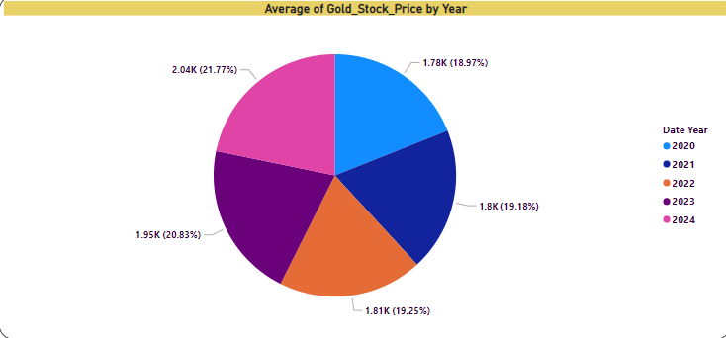

Description: This visualization showcases the average gold stock price over the year.

Insight: Despite the year 2024 having the highest avg. Gold stock price is 2.04k,along with that year 2023 with 1.95k avg. stock price and also year 2022 with 1.81k avg. gold stock price and the year 2021 with 1.8k and the year 2020 with the avg. gold stock price1.78k

**Visualization 3: Average silver stock price over years.**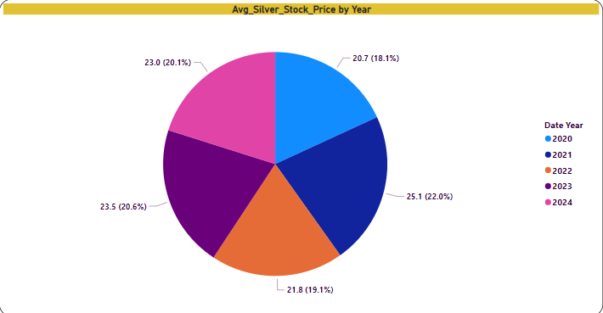

Description: The pie chart illustrates the avg silver stock price over year.

Insight: : Despite the year 2021 having the highest avg. silver stock price is 25.1,along with that year 2023 with 23.5 avg. stock price and also year 2022 with 21.8 avg. silver stock price and the year 2024 with 23.0 and the year 2020 with the avg. silver stock price 20.7 .

**Visualization 4: comparing avg. amazon and avg Netflix stock price**

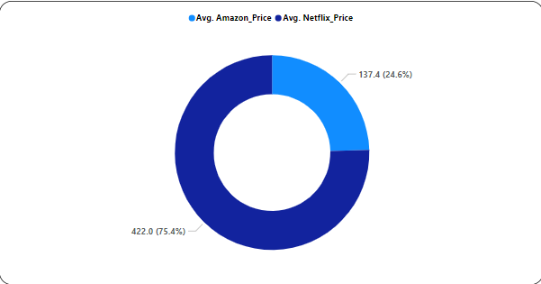

***Description:*** This pie chart displays the avg. amazon and avg Netflix stock price.

***Insight:*** the average amazon stock price all over the years is 137.4 and the average Netflix stock price all over the year is 422.0

**Visualization 5: Average Netflix and average amazon price by years.**

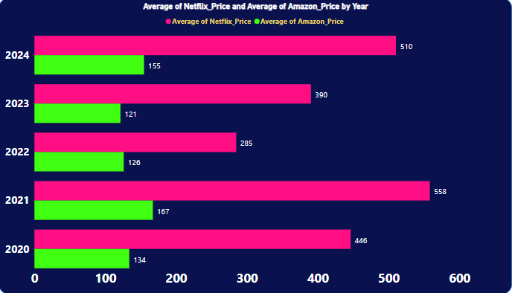

***Description:*** The bar chart depicts the Average Netflix and average amazon price by years.

***Insight:*** Average Netflix stock price in year 2020 is 44 and year 2021 is 558 and year 2022 is 285 and year 2023 is 390 and also in year 2024 is 510.

Average amazon stock price in year 2020 is 134 and in year 2021 is 167 and in year 2022 is 126 and in year 2023 is 121 and in year 2024 is 155.

**Visualization 6: Minimum Meta and Microsoft stock price by year.**

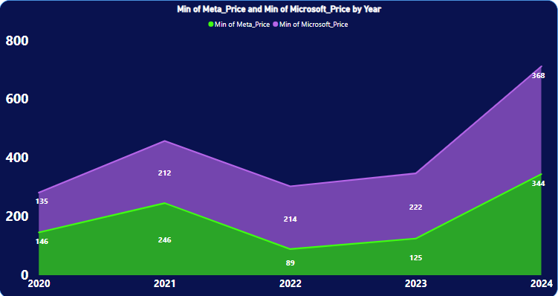

Description: This map visualization illustrates the minimum meta and Microsoft stocks prices by years.

Insight: here we can see in the graph the year 2024 having the minimum meta price is 344 and the minimum Microsoft price is 368.

**Visualization 7: Average apple stock price over years.**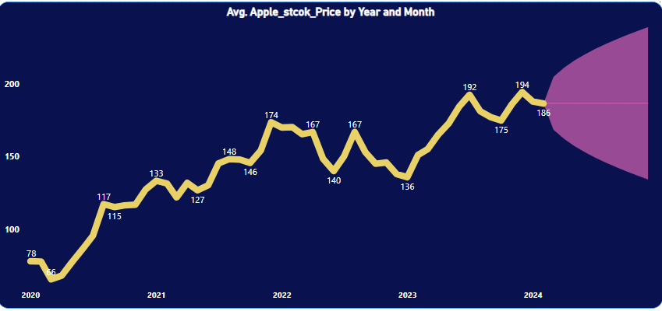

Description: This map visualization illustrates the average stock price over years.

**Visualization 8: Maximum & minimum Bitcoin stock price by year.**

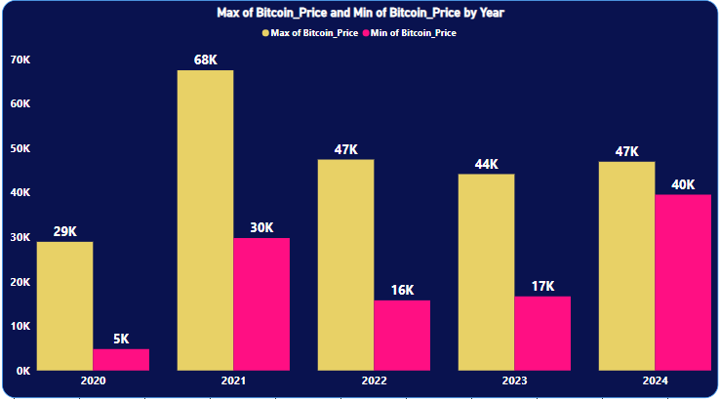

Description: This bar chart visualization illustrates the Maximum and Minimum Bitcoin stock price by years.

Insight: the year 2021 having the highest bitcoin stock price with 68k and the lowest bitcoin stock price in the year 2020 with 5k.

**Visualization 9: Average Apple and Tesla stock price by year.**

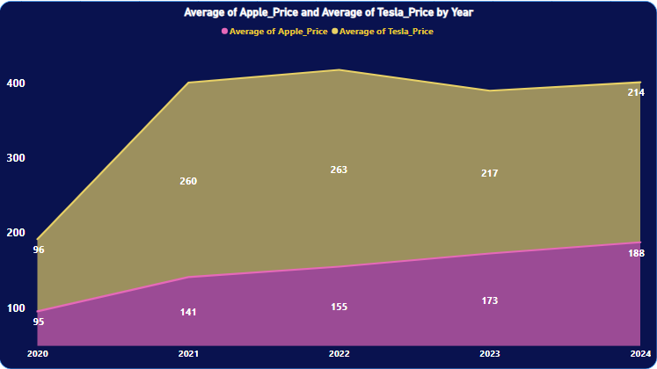

Description: This chart visualization illustrates the comparison of Average Apple and Tesla stock price by year.

Insight: the year 2020 having the avg apple price 95 and avg. tesla price 96 also the year 2021 having the avg apple price 141 and avg. tesla price 260. also the year 2022 having the avg apple price 155 and avg. tesla price 263.also the year 2023 having the avg apple price 171 and avg. tesla price 217. And the year 2024 having the avg apple price 188 and avg. tesla price 214.

**Visualization 10: Excel dashboard of US Stock of year 2020 to 2024.**